PROBLEM SOLVING AND TESTING USING JAVA

NAME: V.NEELA DEVI
VTU NO: 28598
WEEK-3 PROBLEMS

1.Java Date and Time – https://www.hackerrank.com/challenges/java-date-and-time/problem
import java.io.*;
import java.math.*;
import java.security.*;
import java.text.*;
import java.util.*;
import java.util.concurrent.*;
import java.util.function.*;
import java.util.regex.*;
import java.util.stream.*;
import static java.util.stream.Collectors.joining;
import static java.util.stream.Collectors.toList;
class Result {

/*
* Complete the 'findDay' function below.
*
* The function is expected to return a STRING.
* The function accepts following parameters:
* 1. INTEGER month
* 2. INTEGER day
* 3. INTEGER year
*/

public static String findDay(int month, int day, int year) {
// Using java.time.LocalDate to easily find the day of the week
java.time.LocalDate dt = java.time.LocalDate.of(year, month, day);

// Returns the day of the week in capital letters (e.g., WEDNESDAY)
return dt.getDayOfWeek().toString();
}

}
public class Solution {
public static void main(String[] args) throws IOException {
BufferedReader bufferedReader = new BufferedReader(new InputStreamReader(System.in));
BufferedWriter bufferedWriter = new BufferedWriter(new FileWriter(System.getenv("OUTPUT_PATH")));

String[] firstMultipleInput = bufferedReader.readLine().replaceAll("\\s+$", "").split(" ");

int month = Integer.parseInt(firstMultipleInput[0]);

int day = Integer.parseInt(firstMultipleInput[1]);

int year = Integer.parseInt(firstMultipleInput[2]);

String res = Result.findDay(month, day, year);

bufferedWriter.write(res);
bufferedWriter.newLine();

bufferedReader.close();
bufferedWriter.close();
}
}
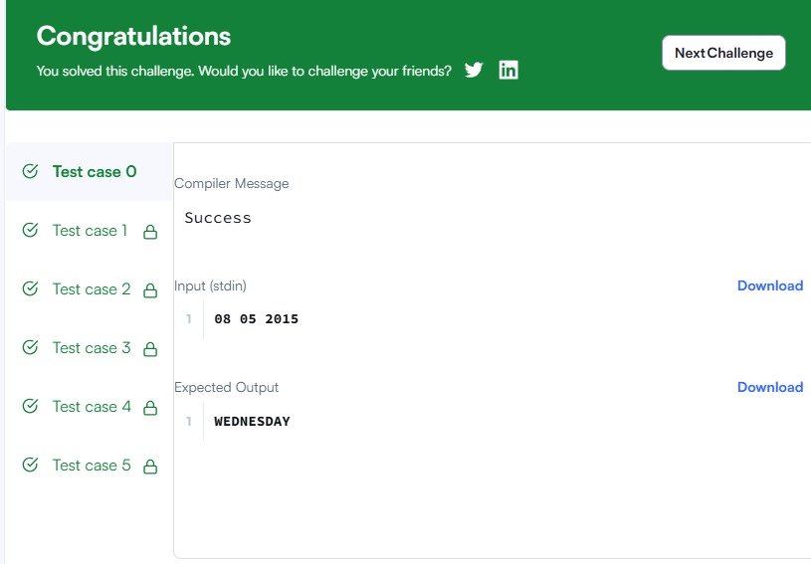
2. Number of Days Between Two Dates – https://leetcode.com/problems/number-of-days-between-two-dates/
import java.time.LocalDate;
import java.time.temporal.ChronoUnit;

class Solution {
public int daysBetweenDates(String date1, String date2) {
LocalDate d1 = LocalDate.parse(date1);
LocalDate d2 = LocalDate.parse(date2);

// Use ChronoUnit.DAYS.between to find the absolute difference in days
return (int) Math.abs(ChronoUnit.DAYS.between(d1, d2));
}
}
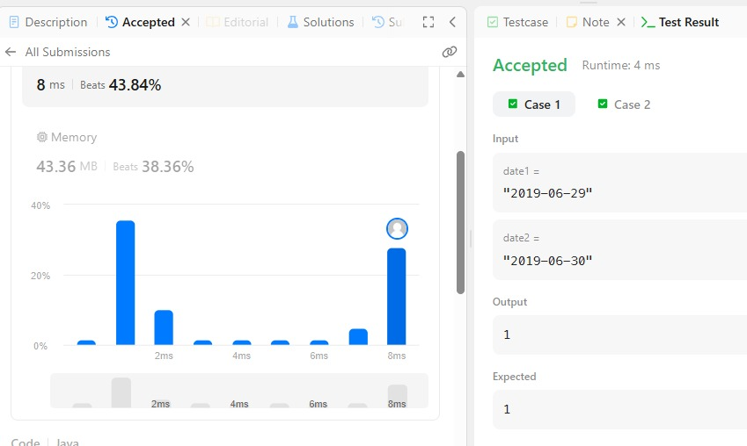
3.Day of the Year – https://leetcode.com/problems/day-of-the-year/
class Solution {
public int dayOfYear(String date) {
// Parse year, month, and day from the string
int year = Integer.parseInt(date.substring(0, 4));
int month = Integer.parseInt(date.substring(5, 7));
int day = Integer.parseInt(date.substring(8, 10));

// Days in each month for a non-leap year
int[] daysInMonths = { 31, 28, 31, 30, 31, 30, 31, 31, 30, 31, 30, 31 };

// Check for leap year and update February's days if necessary
if (isLeapYear(year)) {
daysInMonths[1] = 29;
}

// Sum up the days of the preceding months plus the current day
int dayOfYear = day;
for (int i = 0; i < month - 1; i++) {
dayOfYear += daysInMonths[i];
}

return dayOfYear;
}

private boolean isLeapYear(int year) {
// A year is a leap year if it is divisible by 4 and not 100,
// or if it is divisible by 400.
return (year % 4 == 0 && year % 100 != 0) || (year % 400 == 0);
}
}
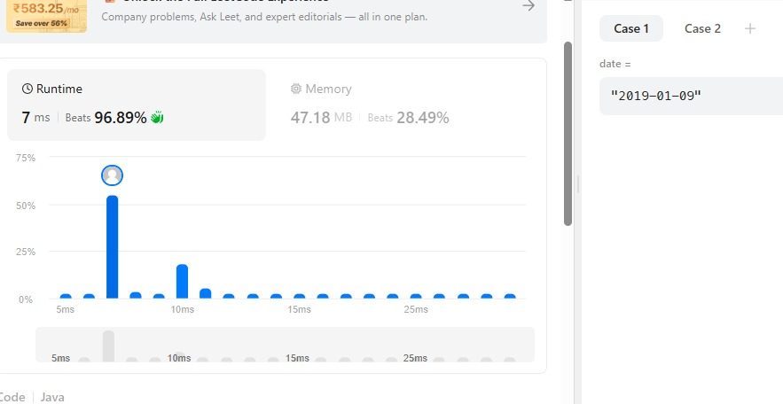

4.Day of the Week – https://leetcode.com/problems/day-of-the-week/
import java.time.LocalDate;
import java.time.format.TextStyle;
import java.util.Locale;

class Solution {
public String dayOfTheWeek(int day, int month, int year) {
LocalDate date = LocalDate.of(year, month, day);
return date.getDayOfWeek().getDisplayName(TextStyle.FULL, Locale.ENGLISH);
}
}
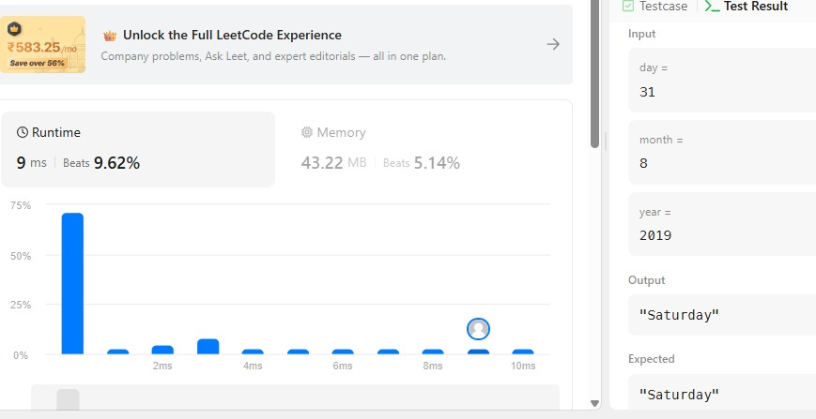

5. Java Priority Queue – https://www.hackerrank.com/challenges/java-priority-queue/problem
import java.util.ArrayList;
import java.util.List;
import java.util.Scanner;
import java.util.Comparator;
import java.util.PriorityQueue;

class Student {
private int id;
private String name;
private double cgpa;

public Student(int id, String name, double cgpa) {
this.id = id;
this.name = name;
this.cgpa = cgpa;
}

public int getID() {
return id;
}

public String getName() {
return name;
}

public double getCGPA() {
return cgpa;
}
}

class Priorities {
public List<Student> getStudents(List<String> events) {
PriorityQueue<Student> pq = new PriorityQueue<>(
Comparator.comparing(Student::getCGPA).reversed()
.thenComparing(Student::getName)
.thenComparing(Student::getID)
);

for (String event : events) {
String[] parts = event.split("\\s+");
if (parts[0].equals("ENTER")) {
String name = parts[1];
double cgpa = Double.parseDouble(parts[2]);
int id = Integer.parseInt(parts[3]);
pq.add(new Student(id, name, cgpa));
} else if (parts[0].equals("SERVED")) {
pq.poll();
}
}

List<Student> students = new ArrayList<>();
while (!pq.isEmpty()) {
students.add(pq.poll());
}

return students;
}
}

public class Solution {
private final static Scanner scan = new Scanner(System.in);
private final static Priorities priorities = new Priorities();

public static void main(String[] args) {
int totalEvents = Integer.parseInt(scan.nextLine());
List<String> events = new ArrayList<>();

while (totalEvents-- != 0) {
String event = scan.nextLine();
events.add(event);
}

List<Student> students = priorities.getStudents(events);

if (students.isEmpty()) {
System.out.println("EMPTY");
} else {
for (Student st: students) {
System.out.println(st.getName());
}
}
}
}
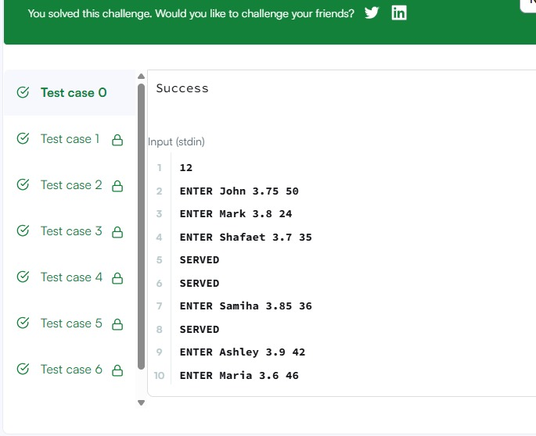

6.Java Arraylist – https://www.hackerrank.com/challenges/java-arraylist/problem
import java.io.*;
import java.util.*;

public class Solution {

public static void main(String[] args) {
Scanner scan = new Scanner(System.in);

// Read the number of lines
int n = scan.nextInt();

// Create an ArrayList of ArrayLists to store the integers for each line
ArrayList<ArrayList<Integer>> lines = new ArrayList<>();

for (int i = 0; i < n; i++) {
int d = scan.nextInt();
ArrayList<Integer> row = new ArrayList<>();
for (int j = 0; j < d; j++) {
row.add(scan.nextInt());
}
lines.add(row);
}

// Read the number of queries
int q = scan.nextInt();

for (int i = 0; i < q; i++) {
int x = scan.nextInt(); // Line number
int y = scan.nextInt(); // Position number

// Convert 1-based indexing to 0-based indexing
try {
System.out.println(lines.get(x - 1).get(y - 1));
} catch (IndexOutOfBoundsException e) {
System.out.println("ERROR!");
}
}

scan.close();
}
}

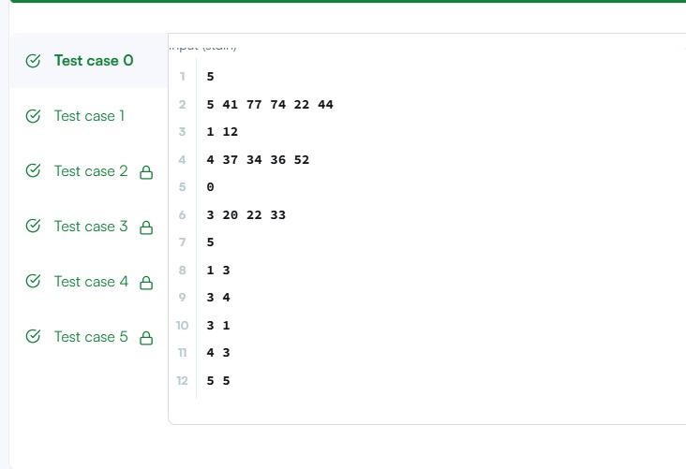
7.Largest Number – https://leetcode.com/problems/largest-number/
import java.util.Arrays;

class Solution {
public String largestNumber(int[] nums) {
// Convert the integer array to a String array
String[] strNums = new String[nums.length];
for (int i = 0; i < nums.length; i++) {
strNums[i] = String.valueOf(nums[i]);
}

// Sort the strings using a custom comparator
// Compare (b + a) with (a + b) to decide the descending order arrangement
Arrays.sort(strNums, (a, b) -> (b + a).compareTo(a + b));

// Edge case: if the highest number is "0", the entire array consists of zeros
if (strNums[0].equals("0")) {
return "0";
}

// Build the final largest number string
StringBuilder sb = new StringBuilder();
for (String str : strNums) {
sb.append(str);
}

return sb.toString();
}
}

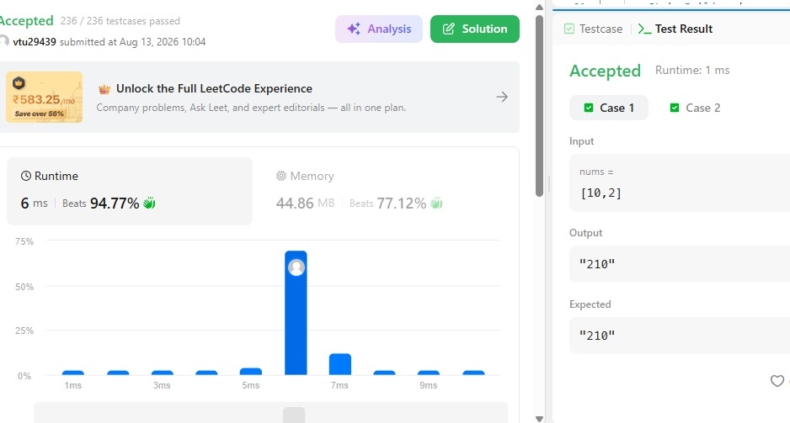

8.Java Comparator: https://www.hackerrank.com/challenges/java-comparator/problem
import java.util.*;
class Checker implements Comparator<Player> {
@Override
public int compare(Player a, Player b) {
if (a.score != b.score) {
return Integer.compare(b.score, a.score); // Decreasing order of score
}
return a.name.compareTo(b.name); // Alphabetical order of name
}
}
class Player{
String name;
int score;

Player(String name, int score){
this.name = name;
this.score = score;
}
}

class Solution {

public static void main(String[] args) {
Scanner scan = new Scanner(System.in);
int n = scan.nextInt();

Player[] player = new Player[n];
Checker checker = new Checker();

for(int i = 0; i < n; i++){
player[i] = new Player(scan.next(), scan.nextInt());
}
scan.close();

Arrays.sort(player, checker);
for(int i = 0; i < player.length; i++){
System.out.printf("%s %s\n", player[i].name, player[i].score);
}
}
}
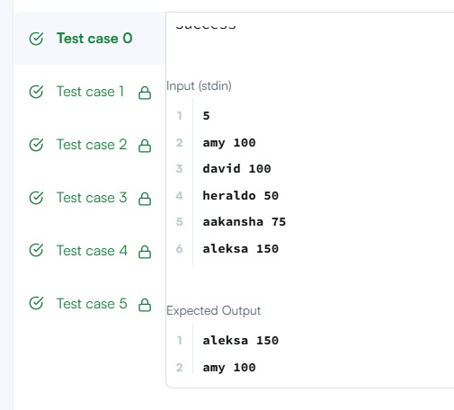
9.Sort the People- https://leetcode.com/problems/sort-the-people/
import java.util.Arrays;

class Solution {
public String[] sortPeople(String[] names, int[] heights) {
int n = names.length;

// Create an array of indices to keep track of the original positions
Integer[] indices = new Integer[n];
for (int i = 0; i < n; i++) {
indices[i] = i;
}

// Sort the indices based on the heights in descending order
Arrays.sort(indices, (a, b) -> Integer.compare(heights[b], heights[a]));

// Build the result array using the sorted indices
String[] result = new String[n];
for (int i = 0; i < n; i++) {
result[i] = names[indices[i]];
}

return result;
}
}

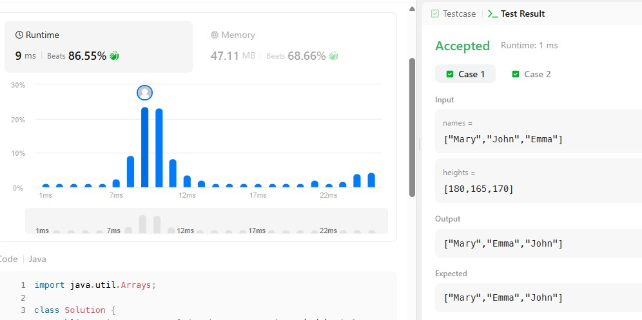

THANK YOU

